**Student Database Application – User Manual**

1. Click the *START* button on the *Main* worksheet to load the file dialog box and select the student database to be used. The dialog box will only load Access database files (*.accdb*). The program does not check to see that a specific access file was loaded, just in case other database files with different names need to be used. So ensure you select the correct database file.
   1. If the wrong database was selected, click the ‘X’ button in the top right corner of the user form that pops up and repeat step one.

**Figure 1:** Main Sheet

**Figure 2:** File Dialog Box to Select the Database

1. Once a database file is selected, a user form will pop up titled ‘*Student Database*’. This is the main ‘dashboard’ of the application.
   1. The dashboard can be easily exited by clicking the ‘X’ button in the top right corner of the form.

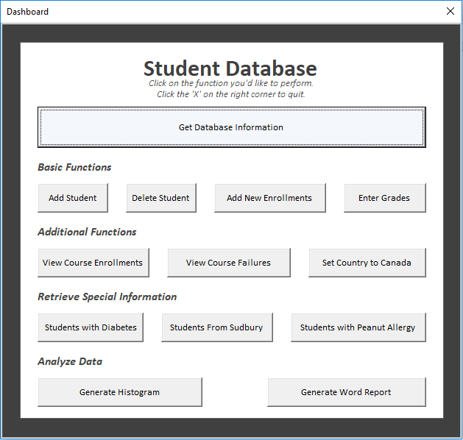

**Figure 3:** Dashboard

1. All the available functionalities of the application are accessed on the dashboard by clicking the button with the caption describing the procedure to be performed.
2. The buttons outlined in **Figure 4** will prompt you with another form for more information that is required to perform the procedure.

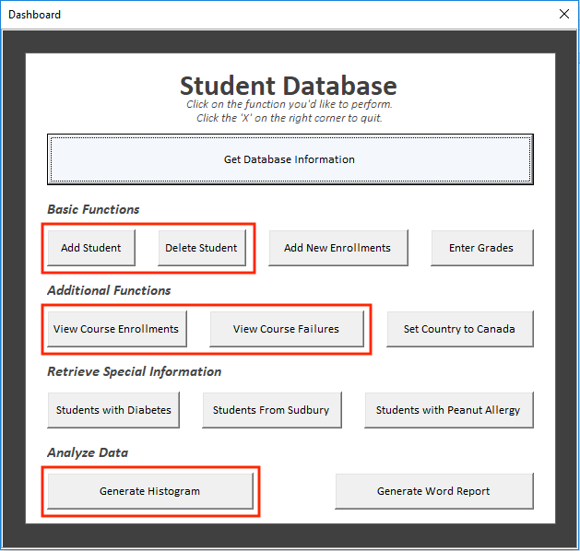

**Figure 4:** Buttons That Prompt for More Information

* 1. Some will ask for inputs in a text box (**Figure 5**), while others will ask you to select certain criteria from a list (**Figure 6**).

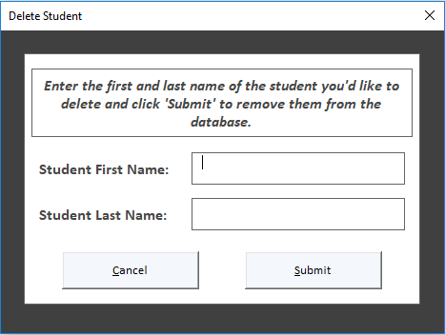

**Figure 5:** Textbox Example **Figure 6:** Listbox Example

1. The other forms (those other than the dashboard, such as those shown in **Figure 5** and **6**) can be exited by clicking the ‘X’ in the top right corner of the form, or by clicking the *Cancel* button on the bottom left of the form.
2. Any information outputted by the subroutines will either be displayed on a separate worksheet, in a message box, or in a new word document. A message box should indicate the output type when the procedure has finished running.
   1. If the procedure fails, however, a message box should indicate the procedure was unsuccessful and no other information should be outputted.
3. I hope that with the assistance of this manual, the Student Database Application is easy and straightforward to use! Enjoy.

***NOTE****:* When using the sample dataset given, you must first import new student information using the *“Add New Enrolments*” button and selecting the *new_enrolments.*dat file before using the application. The students’ grades must also be uploaded using the *“Enter Grades*” button and selecting the *grades.dat* file.